Investigating Windows
Written By: Yuval Quina
I started this challenge by connecting to the target machine using Remote Desktop Protocol (RDP):
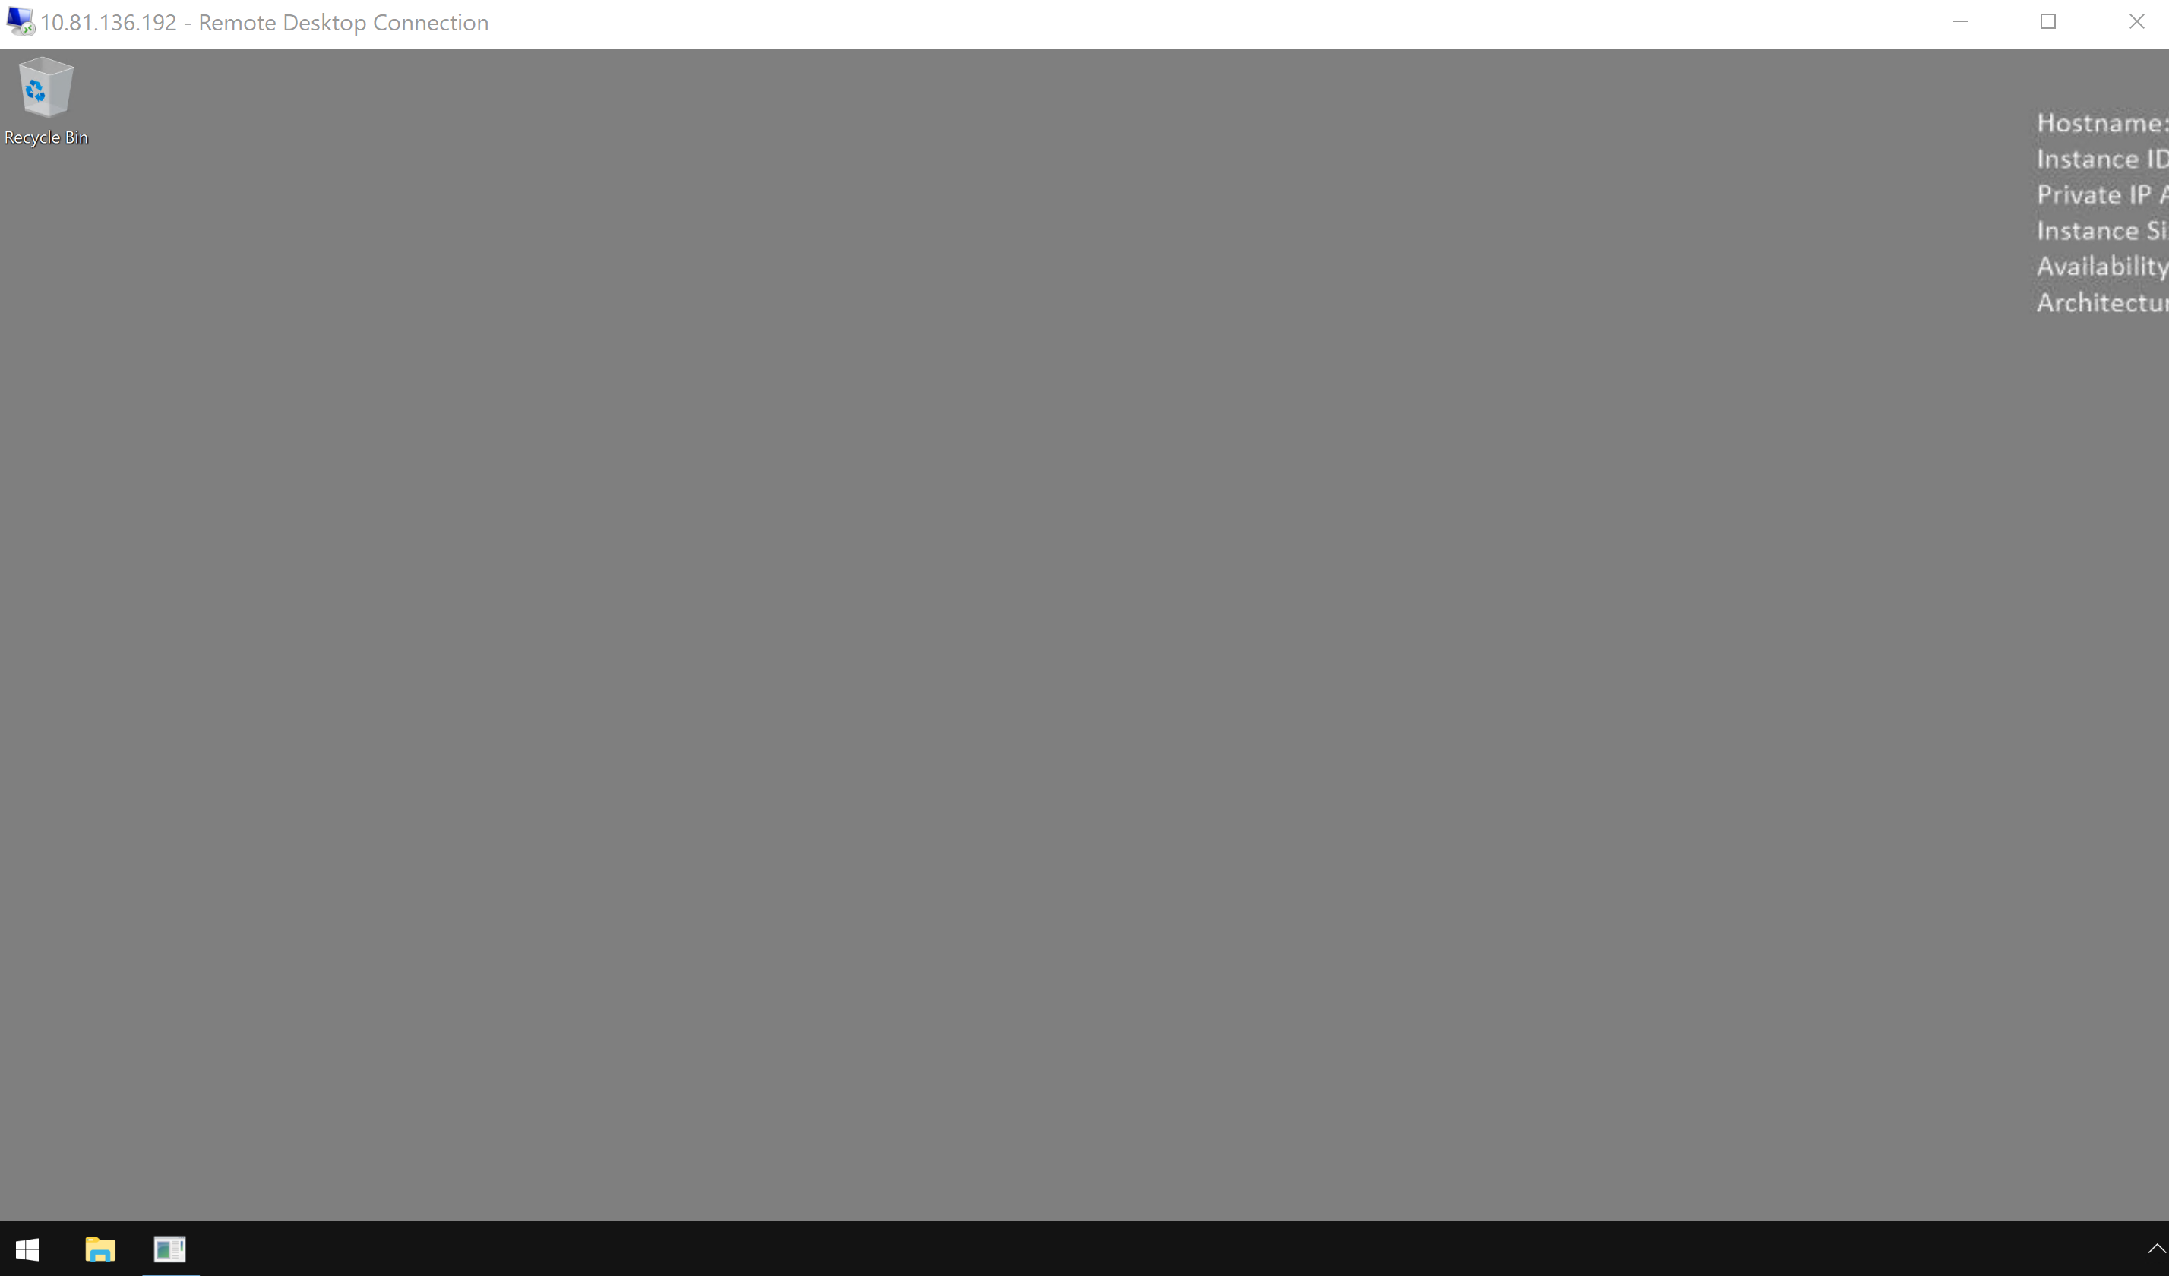
Then, I opened the CMD and wrote the “systeminfo” command to find information about this Windows machine:
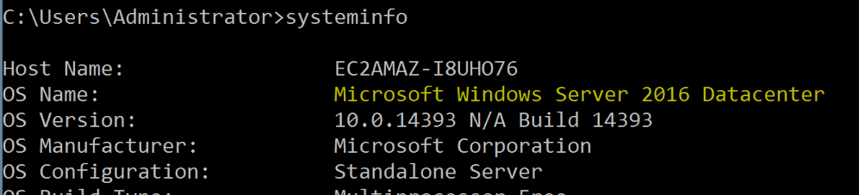
I found that this Windows machine is “Windows Server 2016”.
Afterwards, I check which user connected before me:
and this user was “administrator”.
Thereafter, I searched for the last time the user “John” was logged in:
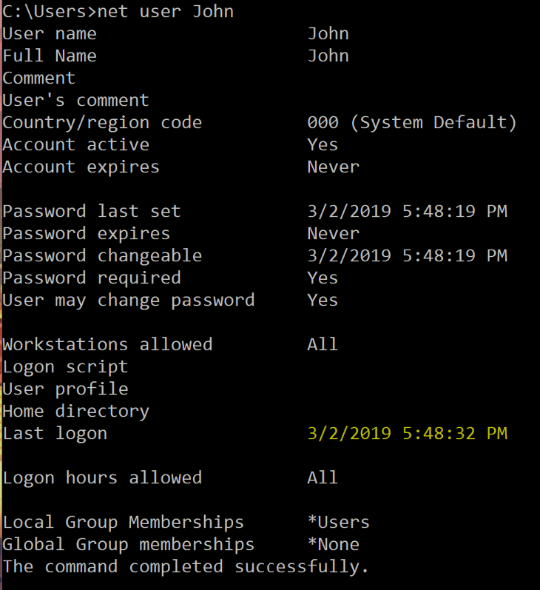
and this at “3/2/2019 5:48:32 PM”
After finding it, I moved to find what was the first ip that the Windows machine was connected to.
I know that first of all, when a windows or linux machine want to connect to a specific host, they perform a process called “DNS lookup”. This process, in short, search for the actual IP of a specific domain that it wants to connect to its host. This process starts, by default, with searching for the IP of the domain in a file named “hosts”. This files path of Windows OS is on “C:\Windows\System32\drivers\etc\hosts”.
I opened this file to find it:
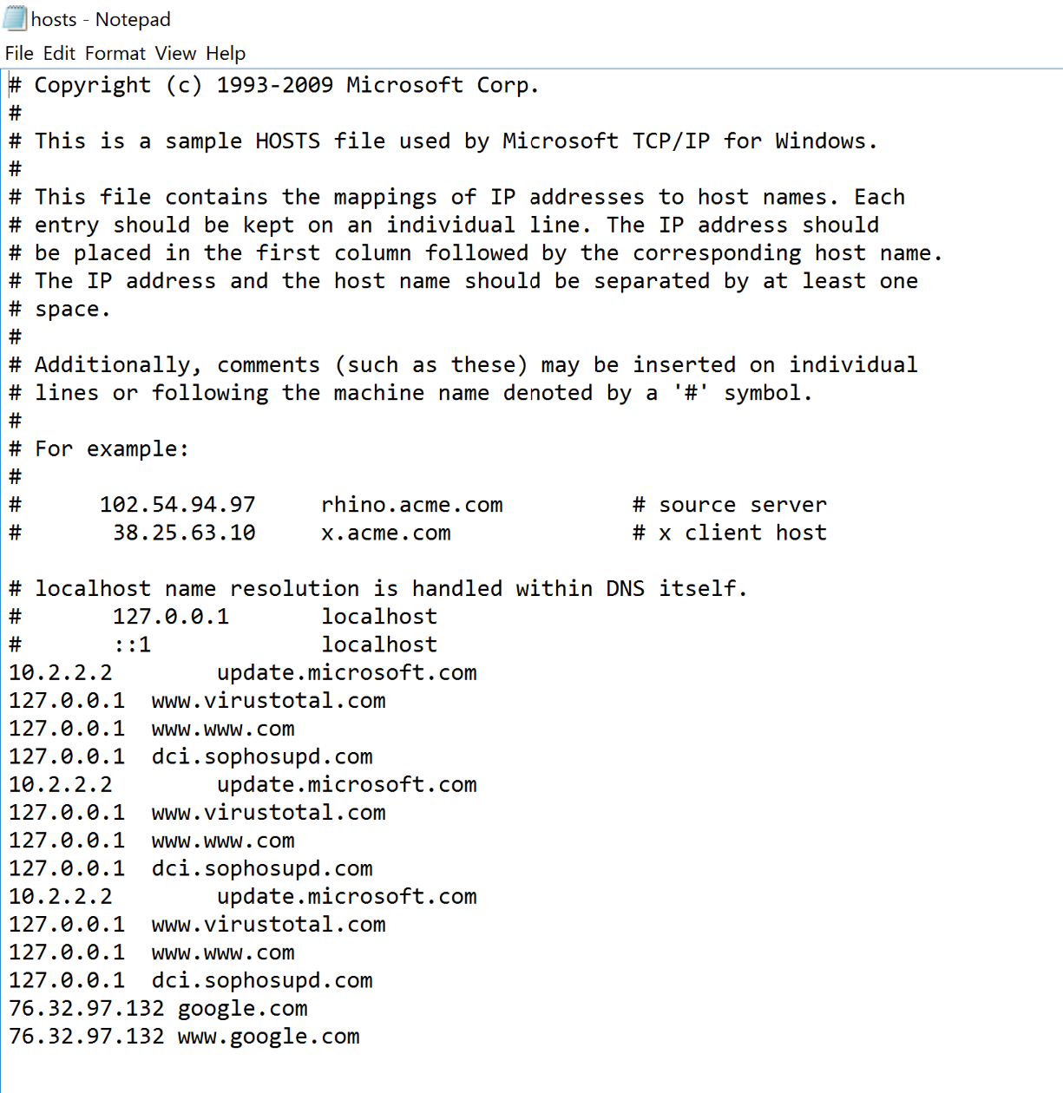
Unfortunately, I found that this file was corrupted (probably by DNS poisoning).
Therefore, I went to the Registry to maybe find a clue at the auto running apps that the machine runs auto anytime it starts up:
I went to HKEY_LOCAL_MACHINE -> SOFTWARE -> Microsoft -> Windows -> CurrentVersion -> Run.
and there I found that it runs a program named “p.exe” that probably create a connection with the ip “10.34.2.3”.

At this point, I needed to check for the 2 users (other that “Administrator”) who had administrator privileges. This lead me to inspect the groups that each user is in to find which users are on the “Administrators” group:
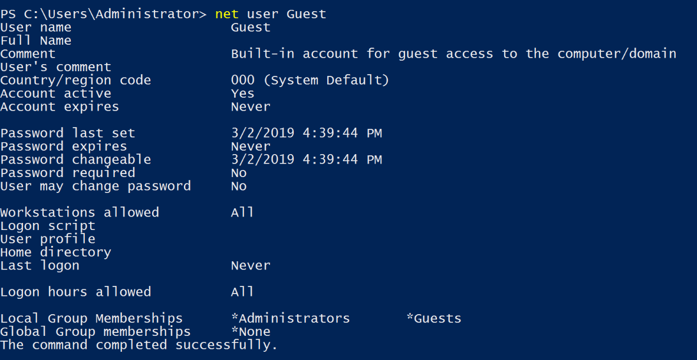
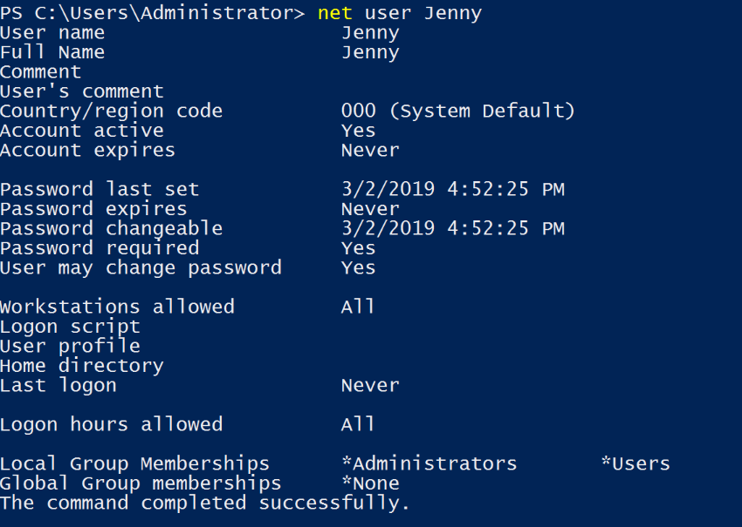
Here, I found that users “Guest” and “Jenny” are part of the “Administrators” group so it means that they had administrator privileges.
Now, I went to the Task Scheduler to see the malicious scheduled task:
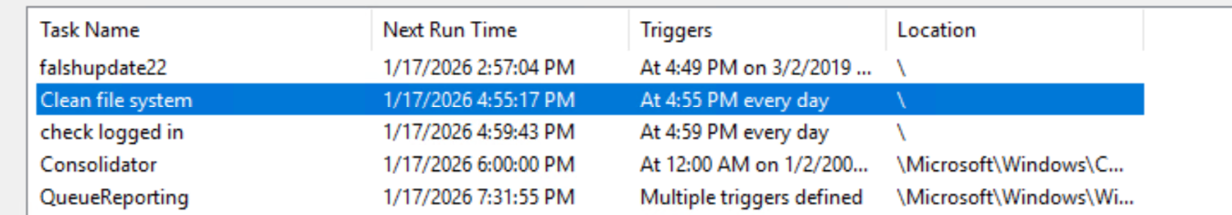
I noticed a strange task named “Clean file system” that shouldn’t be there by default.
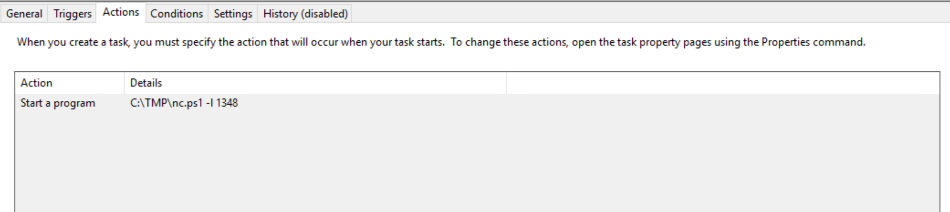
This task tries to run a file named “nc.ps1” and it seems to listen local on port 1348.
Additionally, I noticed that Jenny never logged in the machine.

Afterwards, I moved to check when did the compromise take place. I entered to C:\\ and saw this:
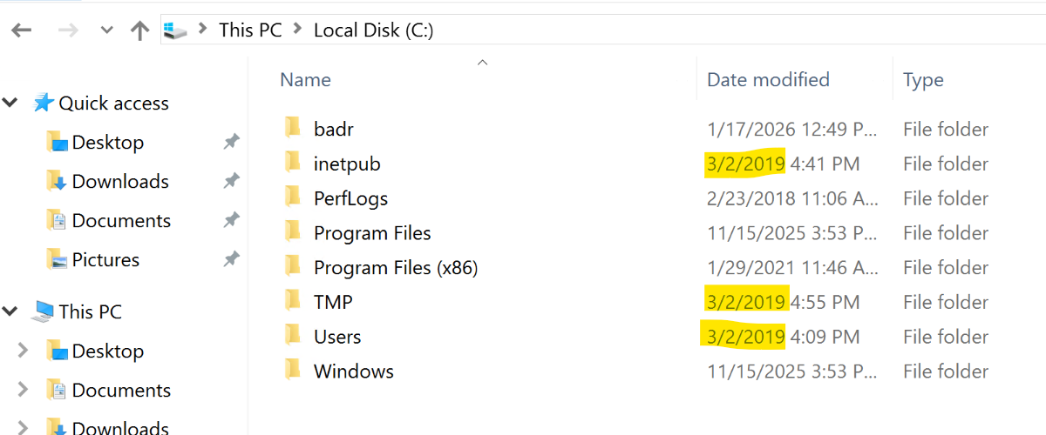
I noticed a folder named “inetpub” that shouldn’t be here and that it connected by the same date to the directories “TMP” and “Users”, so it means that it probably happened on this date “3/2/2019”.
Then I entered the Event Viewer to see at what time did Windows first assign special privileges to a new logon:

